Iris Obscura:
An exhibition by
Joanna Manousis

Press Release
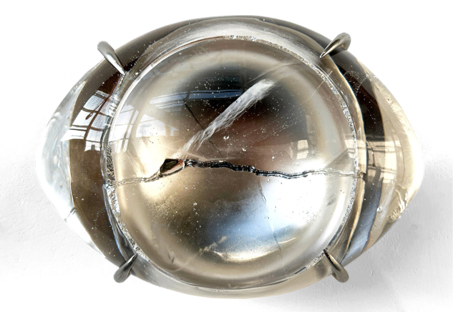
For immediate release
12/02/2024
Contact: Alex Breeze
Company: Breeze Creatives
Address: Abject Gallery, Fawcett Street, Sunderland, SR1 1RE
Telephone: 07751017565
Email: info@breezecreatives.com
URL: www.abject.gallery

SUNDERLAND, PREVIEW: FRIDAY 26TH APRIL 2024, 6PM – 8PM
Abject Galley is pleased to announce an exhibition showcasing ground-breaking sculptures by British-American artist Joanna Manousis .
Joanna Manousis, a British-American artist known for her monumental and intimate-scale sculptures in glass, mirror, and mixed media, is set to captivate audiences with her latest exhibition, "Iris Obscura." Drawing on two decades of studio practice and three years of academic research, Manousis presents an innovative exploration of mirrored glass as a medium for artistic expression.
With a career marked by international acclaim, Manousis has continuously pushed the boundaries of traditional sculpture, inviting viewers to experience shifts in perception and an altered sense of reality. Her work, which often imitates other materials and recognisable objects, delves into themes of materialism, memory, domesticity, and vanity, inviting introspection and reflection.
"Iris Obscura" represents the culmination of Manousis’ extensive research of cast glass mirrors, a technique historically overlooked in mirror-making due to its textured, opaque surface. Through meticulous experimentation, Manousis has harnessed the potential of investment cast glass as a canvas for silver nitrate coatings, creating a mesmerising palette of surface effects.
The centrepiece of the exhibition, funded in part by Arts Council England, is a 400+ part wall installation of glass prisms with multi-faceted mirrored interiors. Handcrafted and digitally fabricated, this monumental work responds dynamically to the expansive walls and natural light of the Abject galleries exhibition space, inviting visitors into a realm of visual enchantment.
Accompanying the installation are over 100 cast glass mirror samples created during Manousis' PhD studio research, along with a series of sculptures that upturn the reflected ‘truth’ that a mirror evokes.
Manousis' artistic prowess has earned her a place among the most esteemed artists in the field. Her works are held in major public collections across the USA and Europe, including The Ringling Museum in Florida, The Glasmuseet in Denmark, and the European Museum of Modern Glass in Germany. She has received nominations for prestigious awards such as the Louis Comfort Tiffany Foundation Award and the Bombay Sapphire Award for Excellence in Glass.
In addition to her artistic achievements, Manousis is also a dedicated AHRC (Northern Bridge) scholar, currently pursuing a PhD at The National Glass Centre, through the University of Sunderland, UK, focusing on the innovative use of three-dimensional cast glass mirrors. She holds a Master of Fine Arts in Sculpture from Alfred University, New York, and a Bachelor's Degree in Fine Art–Glass from The University of
Wolverhampton, England.
Throughout her career, Manousis has benefited from internationally recognised residency programs, including those at the Glass Pavilion at the Toledo Museum of Art, the Museum of Arts and Design in New York, the Corning Museum of Glass in New York, and Cité Internationale des Arts in Paris, France. Her passion for art has taken her around the globe, where she has worked, studied, and taught in Japan, the United Kingdom, the United States, and Australia.
"Iris Obscura" promises to be a transformative experience for art enthusiasts and novices alike, offering a glimpse into Joanna Manousis' visionary exploration of glass as a medium for artistic expression.
About Joanna Manousis:
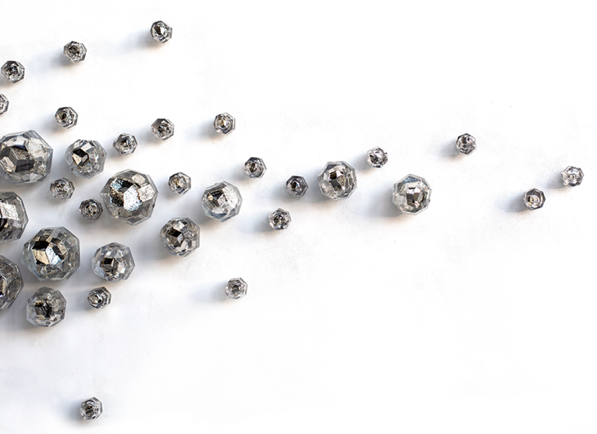
Joanna Manousis is a British-American artist renowned for her monumental and intimate-scale sculptures in glass, mirror, and mixed media. With an international exhibition record and works held in major public collections across the USA and Europe. Manousis' art invites viewers to explore themes of materialism, memory, domesticity, and vanity. She is currently a PhD researcher at The National Glass Centre, UK, focusing on the innovative use of three-dimensional cast glass mirrors.
About the Exhibition:
"Iris Obscura" is a ground-breaking exhibition by Joanna Manousis, showcasing two decades of studio practice and three years of academic research. Funded in part by Arts Council England, the exhibition features a 400+ part wall installation of glass prisms with multi-faceted mirrored interiors, alongside over 100 cast glass mirror samples and a series of sculptures exploring narratives associated with reflection within historical and contemporary society.

The preview for this exhibition takes place on Friday 26th April, 6 – 8pm with the exhibition continuing to be open from 2nd May – 24th May, Thursday to Saturday, 12pm – 4pm, or by appointment. Entry is free.
Abject Gallery, run by Breeze Creatives, is a contemporary art gallery, in Sunderland city centre that exhibits a selection of national and international artists. Located on Fawcett street, the gallery is also known for its stunning exhibition space and its historic links to Sunderland’s cultural past.

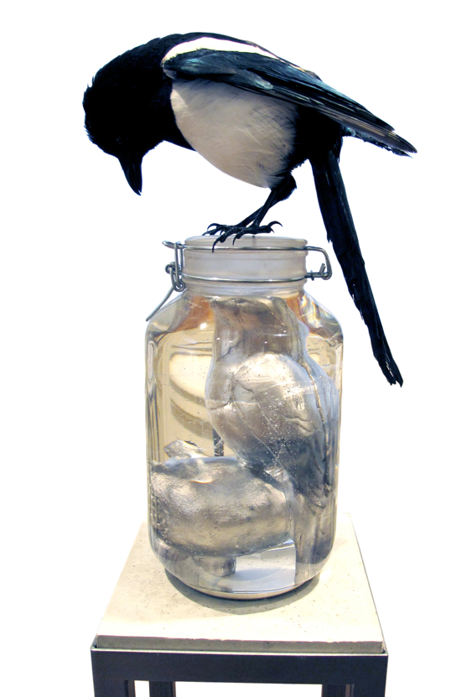
More information is available at www.abject.gallery
Iris Obscura
Preview: Friday, 26th April 2024, 6:00pm – 8:00pm
Exhibition: 2nd May – 24th May 2024
Opening Times: Thur – Sat, 12:00pm – 4:00pm
Location: Abject Gallery, Fawcett St, Sunderland SR1 1RE

- ENDS -

Information for editors
For media enquiries contact Zoe Breeze: zoe@breezecreatives.com.
Additional images can be emailed upon request.

- Breeze Creatives, based in Newcastle upon Tyne and Sunderland specialises in cultural projects and events around the North East of England, and provides artist studios and project spaces in Newcastle and Sunderland city centre. Breeze Creatives latest projects include Abject Gallery, a contemporary art gallery exhibiting a mixture of national and international emerging artists. breezecreatives.com
- Abject Gallery, run by Breeze Creatives, is a contemporary art gallery, in Sunderland city centre that exhibits a selection of national and international artists. Located on Fawcett street, Sunderland, the gallery is also known for its stunning exhibition space and its historic links to Sunderlands cultural past. www.abject.gallery

